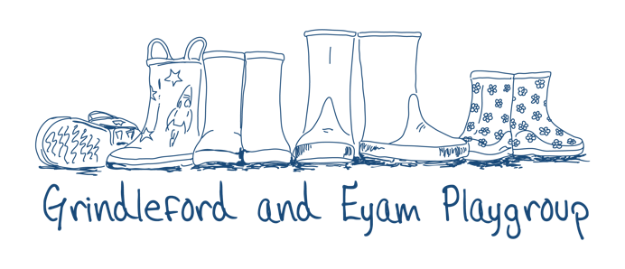
About Us.

Our Ethos - Grindleford and Eyam Playgroup is a small, rural setting based in the beautiful Peak District. Our dedicated team of childcare practitioners are passionate about providing a safe, environment where children are encouraged to freely explore, discover, learn, and take appropriate risks. Our high adult to child ratios enables us to provide endless opportunities for new experiences and challenges, improving children’s educational, physical and social skills by bringing learning to life, increasing confidence and independence whilst nurturing self-esteem and resilience.

How We Achieve This - We hugely value the benefits of outdoor play, and our weekly routine incorporates endless opportunity to explore our natural environment. Through our forest school sessions, woodland walks, gardening at our local allotment and visits to the village shop, in addition to free play outdoors whilst at the Pavilion, children are allowed the freedom to investigate at their own pace under the supervision of practitioners. Our open-door approach supports our child-led play, enabling children to decide exactly what they want to do, how they want to do it and where. Children have plenty of time every day to develop their curiosity and confidence, growing in independence every week. We encourage children to make use of all our natural resources to create games, work together, solve problems and enjoy time with friends both inside and outside.

Our Routine – We have structured daily and weekly routines, whilst our activities over the year focus on the themes of the seasons and major cultural festivals. Our daily routine is carefully planned to include a balance of structured, adult led activities such as circle time, storyland and crafts, and long periods of free play. The familiarity of our day enables children to feel secure and settled. Throughout the day children are given opportunity to explore the seven areas of learning naturally, and at their own pace.

